1. Unit testing

|  |  |  |  |  |  |
| --- | --- | --- | --- | --- | --- |
| **No** | **Title** | **Pre-Condition** | **Test Steps** | **Expected Result** | **Actual Result** |
| 1.1 | Dealing with enquiries | Admin must logged in | See the enquiries from user and reply them on their email. | Admin can check enquiries and make reply | Yes, admin can |

02. Integration Testing

Integrations testing performed to find out integrated modules of the website work as expected or not. This testing method tests integration between different pages of the system. The following test process is followed for integration testing -

|  |  |  |  |  |  |
| --- | --- | --- | --- | --- | --- |
| **No** | **Title** | **Test Steps** | **Expected Result** | **Actual Result** | **Action Taken** |
| 2.1 | Integration Testing | User click on research button | The system will redirect to the research pages of the system. | Yes, The system redirected to the research page successfully. | None |
| 2.2 | Integration Testing | Clicking on about page button | It will redirect to the about pages of the system. | Successfully redirected to the page and test was successful. | None |

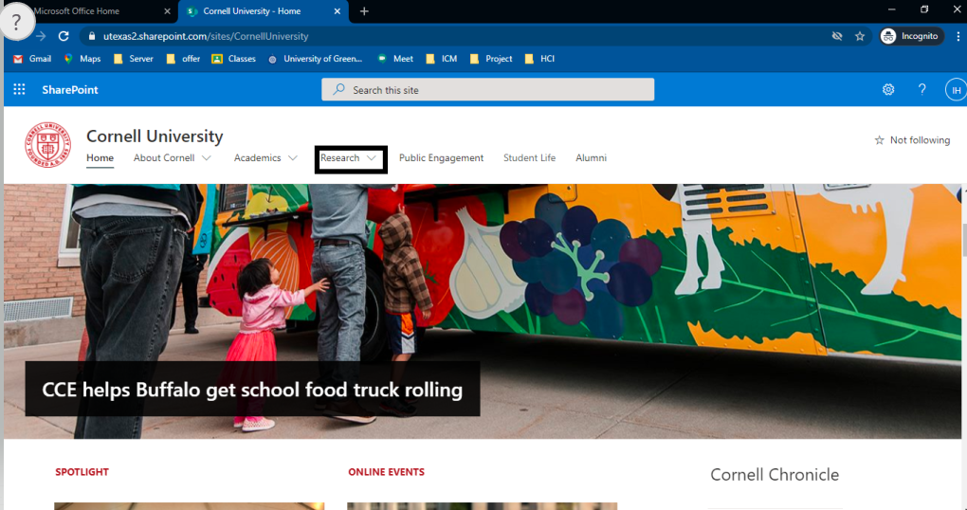

Figure 1.1 Clicking on research tab from home.

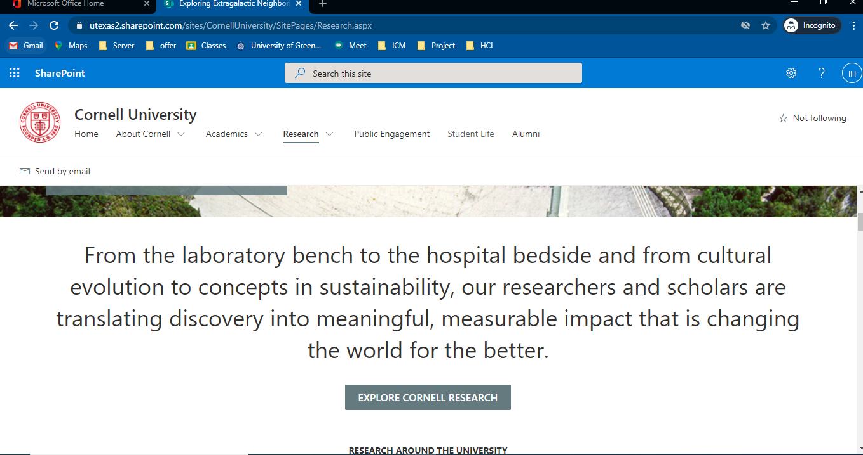

Figure 2.2: redirected to the research page



Figure 3: Redirect to the about page after clicking on about.